WHO’s FP Guidance Documents and Job Aids:
Facilitator’s Guide to the Training Resource Package

Table of Contents
Module Diagram …………………………………………………………………………… 3
I. What is the Training Resource Package Module on WHO’s FP Guidance Documents?.4
II. What is the Purpose of the Training Resource Package Module on WHO’s FP Guidance Documents? 4
III. Who Can Use the Training Resource Package Module on WHO’s FP Guidance Documents? 4
IV. Using the WHO’s FP Guidance Documents Module to Develop Training 4
V. Using the Training Resource Package Module on WHO’s FP Guidance Documents for Pre-service Training 5
VI. Overview of the Design of the Technical Resource Package Module on WHO’s FP Guidance Documents
(see Diagram, page 3) 5
a. The Learning Objectives 5
b. Illustrative Module Session Plan with Illustrative Training Schedule 5
c. Facilitator’s Guide 6
d. Presentation (PowerPoint slides) 6
e. Handouts 7
f. References 8

Appendices
Appendix A: Adult Learning 11
Appendix B: Illustrative Training Schedule 14
Appendix C: WHO’s FP Guidance Documents: Answer Keys for Pre- and Post-Tests 17
Appendix D: WHO’s FP Guidance Documents: Pre-Test (Participant Copy) 19
Appendix E: WHO’s FP Guidance Documents: Post-Test (Participant Copy) 21
Appendix F: Sample Course Evaluation 23

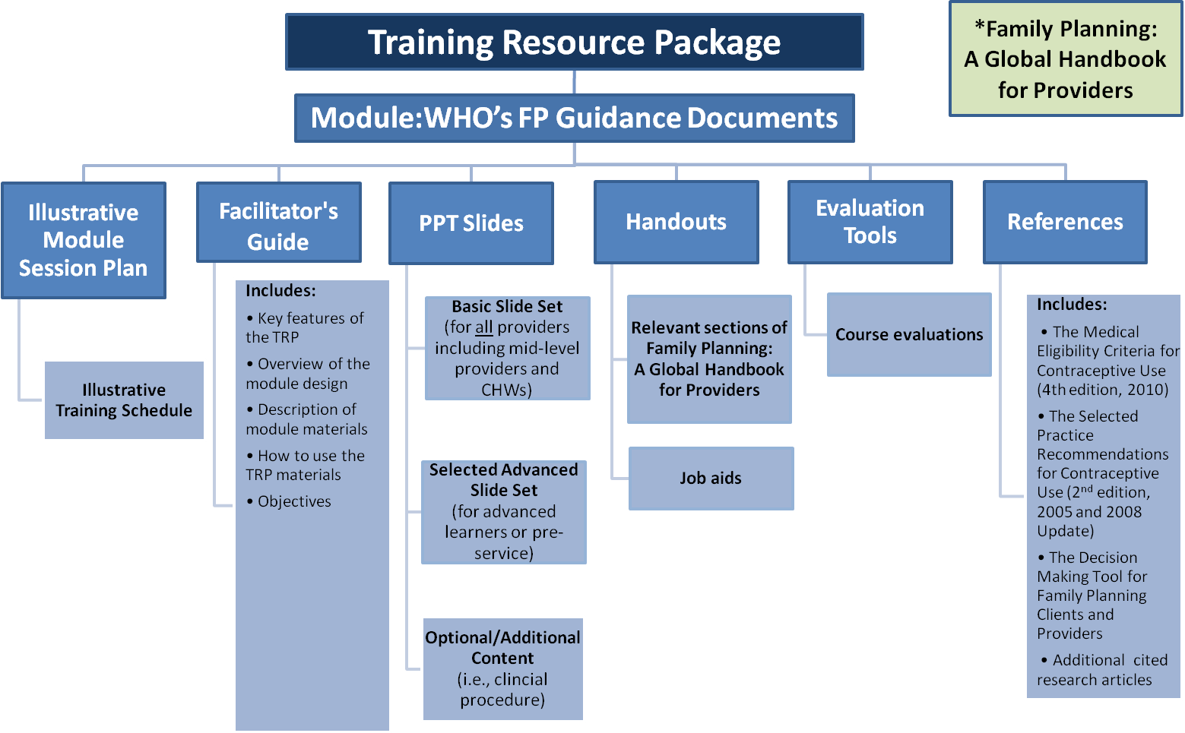
WHO’s FP Guidance Documents:
Facilitator’s Guide to the Training Resource Package
I. What is the Training Resource Package Module on WHO’s FP Guidance Documents and Job Aids?
This Facilitator’s Guide will help you make effective use of the WHO’s FP Guidance Documents and Job Aids module of The Training Resource Package (TRP). The TRP module on WHO’s FP Guidance Documents and Job Aids is part of a global resource package for trainers, supervisors, and program managers. It contains high quality user-friendly materials and resources for designing, conducting and evaluating training for family planning (FP) providers. The resource package is specifically designed for mid-level providers but also contains more advanced materials for physicians and can be adapted for use with lower-level community health workers.
II. What is the Purpose of the Training Resource Package Module on WHO’s FP Guidance Documents?
This training manual was developed for use in training physicians, nurses, and midwives and other health care providers allowed to provide contraceptive methods. It is designed to actively involve the trainees in the learning process. Sessions include PowerPoint presentations, discussions and brainstorming.
III. Who Can Use the Training Resource Package Module on WHO’s FP Guidance Documents and Job Aids?
The training materials are designed to be used by clinical trainers and pre-service educators with a thorough understanding of adult learning principles and the ability to provide clinical training on FP topics in pre-service or in-service settings.
IV. Using WHO’s FP Guidance Documents and Job Aids Module to Develop Training
The diagram following the Table of Contents shows how the different elements of the module fit together. Each piece of the WHO’s FP Guidance Documents module may be adapted to fit the circumstances in the country where they will be used, the trainers who will be conducting training, and the level of expertise and skills of the trainees. The module can be adapted to fit any kind of training e.g., face-to-face or self-study combined with clinical practicum, on-the-job training, etc. The module can be used as an introduction to a comprehensive course in FP. The module can be used as a resource for refresher training or for training new providers. Whenever possible, the module should be translated into the local language. Refer to the Overall Facilitator’s Guide for the eight steps that can be used to develop effective training using the TRP materials.
- Using the Training Resource Package Module on WHO’s FP Guidance Documents and Job Aids for Pre-service Training
Teachers and curriculum developers may use TRP resources for developing a new course or to create teaching materials for an existing pre-service curriculum. While many of the activities involved in developing in-service training also apply to pre-service curricula, (for example, task analysis of job responsibilities, defining prerequisite skills and knowledge), developing pre-service curricula involves a distinctive set of coordinated activities. Describing how to use the TRP in this process would require more extensive instructions than this guide can currently provide. (Detailed advice on using the TRP for pre-service education will be included in a future revision of this guide).
- Overview of the Design of the Training Resource Package Module on WHO’s FP Guidance Documents and Job Aids
Like all of the modules in the TRP, the WHO’s FP Guidance Documents and Job Aids module is a complete package of learning resources needed to address the learning objectives of the module, including a session plan, PowerPoint presentations, and accompanying activities and resources. The module is designed for generic groups of health workers. The WHO’s FP Guidance Documents and Job Aids module materials should be tailored and adapted according to the education and training background and learning needs of the identified trainees.
In order to understand the design of the modules, it is helpful to see the diagram on page three. The basic design includes the following:
- The Learning Objectives
By the end of the training, trainees should be able to:
Explain the purpose and intended use of WHO’s guidelines and job aids:
- Medical Eligibility Criteria for Contraceptive Use (MEC) including job aids
- Selected Practice Recommendations for Contraceptive Use (SPR)
- Family Planning: A Global Handbook for Providers
- Illustrative Module Session Plan with Illustrative Training Schedule
The session plan summarizes how the resources and documents in the module should be used to achieve the learning objectives. Each section of the session plan addresses a module topic, such as characteristics of the method or medical eligibility. The slides to be shown with each section and appropriate handouts are identified. All the module materials and resources are listed on the first few pages of each session plan, with links to the module files. The WHO’s FP Guidance Documents and Job Aids module is very short, with only one session.
The Illustrative Training Schedule provides a snapshot of the breakdown of the module by day, time, and topic covered. For example:

DAY 1
Time | Topic | Method | Resources
8:00-8:15 | Welcome and Introduction  Learning Objectives | Discussion | Slide 2: Objectives
8:15-8:45 | Pre-test | Test | Evaluation Tool: WHO’s FP Guidance Documents Pre-Test

- Facilitator’s Guide
This Facilitator’s Guide contains information on the module design, a description of the materials, learning objectives, how to conduct brainstorming and how to facilitate discussions.

- Presentation (PowerPoint slides)
The PowerPoint presentation includes technical information on WHO’s FP Guidance Documents. In WHO’s FP Guidance Documents and Job Aids module there is only one type of slide:
Slides conveying technical information are pale blue/green:

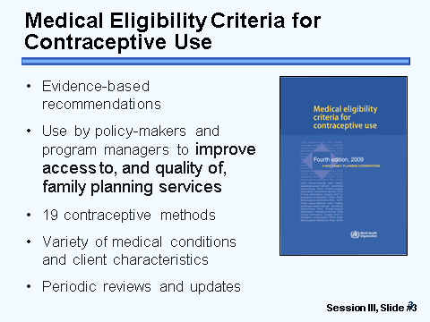

- Handouts
Most of the modules in the TRP contain job aids and counseling tools. Since this module focuses on the WHO guidance documents, it does not include practice on counseling. There are only two handouts, Handout #1: Medical Eligibility Wheel for Contraceptive Use and Handout #2: Quick Reference Chart for Medical Eligibility Criteria. In addition to these handouts it is very helpful to link to the interactive MEC wheel found on the WHO website: http://www.who.int/reproductivehealth/publications/family_planning/wheel_v4_2010_EN.swf

f. Evaluation Tools
The WHO’s FP Guidance Documents and Job Aids module includes pre- and post-tests which contain objective questions, with instructions for scoring the tests.
Pre- and Post-tests
The pre-test knowledge evaluation should be given at the beginning of the course and again at the end of the course (post-test). The trainee’s pre- and post-test scores should be compared to measure changes in knowledge. The pre-test contains the same test items as the post-test. The pre- and post-tests are objective and comprised of true/false and multiple choice questions.
Course Evaluations
The course evaluation is an important first step in determining the success of a training program. Trainees’ reactions help determine the effectiveness of a program and how it can be improved.
The Course Evaluation can’t measure the ability to apply the learning, changes in attitudes or beliefs, organizational impact, or the trainer’s technical knowledge. A Sample Course Evaluation can be found in Appendix F.
Rapid evaluations can be done quickly to determine trainees’ reactions to the day’s session. Ask the following:
- How valuable was today’s session for you using a 5-point scale?
- What are the most important things you learned today?
- How do you plan to apply those ideas to your job?
If you choose not to use the course evaluation form, a quick alternative at the end of training (or during) is to put up two flip charts. On one flip chart write, “Here are some things we found especially useful in the training.” On the other write, “Here are some suggestions for how the training could be even better.” Make sure the trainer leaves the room while the trainees are writing.
Review Exercises and Games
An interesting way to measure what trainees have learned is through the use of review exercises and games. One of these can be found under the evaluation tools section of the website.

- References
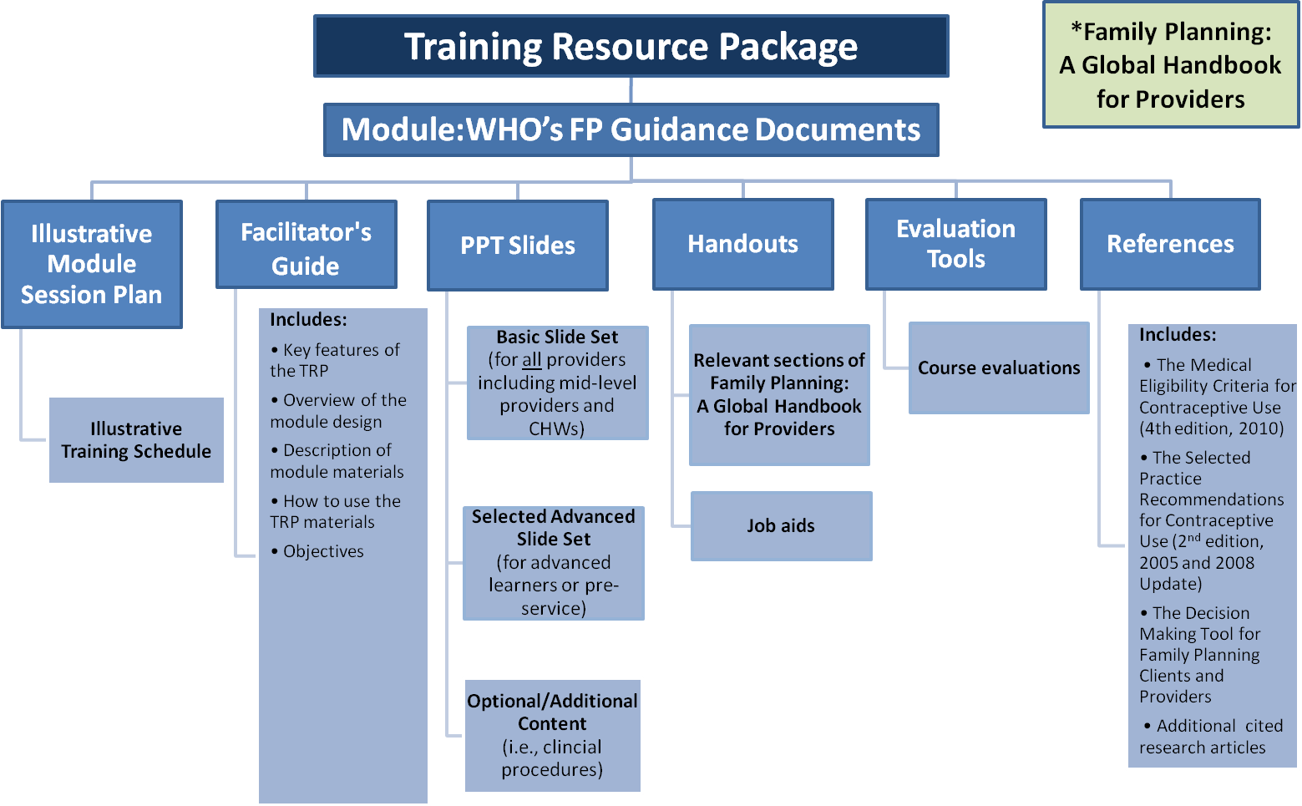
The main references for the WHO’s FP Guidance Documents module as well as for other modules of the TRP are:
- Family Planning: A Global Handbook for Providers (2011 update).This book serves as a quick-reference resource for all levels of health care workers. It provides practical guidance on delivering family planning methods appropriately and effectively. http://www.who.int/reproductivehealth/publications/family_planning/9780978856304/en/index.html
- The Medical Eligibility Criteria for Contraceptive Use (4th edition 2010. This resource provides guidance on whether people with certain medical conditions can safely and effectively use specific contraceptive methods. http://www.who.int/reproductivehealth/publications/family_planning/9789241563888/en/
- Decision-Making Tools for Family Planning Clients and Providers, World Health Organization (WHO) and Johns Hopkins Bloomberg School of Public Health, Center for Communication Programs, Baltimore, Maryland, INFO and Geneva, WHO, 2005. This resource is a comprehensive flip chart that can be used by all types of providers who counsel clients on family planning methods. http://www.who.int/reproductivehealth/publications/family_planning/9241593229index/en/index.html
- The Selected Practice Recommendations for Contraceptive Use (2nd Edition 2005) and the Selected Practice Recommendations for Contraceptive Use: (2008 Update). Provides guidance on how to use contraceptive methods safely and effectively, once they are deemed to be medically appropriate. http://www.who.int/reproductivehealth/publications/family_planning/9241562846index/en/index.html
- A Guide to Family Planning for Community Health Workers and Their Clients, World Health Organization , Geneva, WHO, 2012.This simple counseling tool was adapted from WHO’s Decision-Making Tool for Family Planning Clients and Providers. http://www.who.int/reproductivehealth/publications/family_planning/9789241503754/en/index.html
- The WHO Eligibility Wheel is a tool that makes it easy to identify medical eligibility for use of family planning methods. http://www.who.int/reproductivehealth/publications/family_planning/9789241547710/en/index.html
- The WHO Reproductive Health Library (RHL), The WHO Reproductive Health Library (RHL) is an electronic review journal published by the Department of Reproductive Health and Research at WHO Headquarters in Geneva, Switzerland. RHL takes the best available evidence on sexual and reproductive health from Cochrane systematic reviews and presents it as practical actions for clinicians (and policy-makers) to improve health outcomes, especially in developing countries. http://apps.who.int/rhl/en/

Other resources related to WHO’s FP Guidance Documents:
1. World Health Organization, Department of Reproductive Health and Research (WHO/RHR). Statements:
  - Combined hormonal contraceptive use during the postpartum period. Geneva: WHO, 2010.
  - Progestogen-only contraceptive use during lactation and its effects on the neonate http://www.who.int/reproductivehealth/publications/family_planning/WHO_RHR_09_13/en/index.html
  - Clarification of WHO's position on COC carcinogenicity http://www.who.int/reproductivehealth/publications/ageing/carcinogenicity_hrt/en/index.html
  - Risk of STI acquisition http://www.who.int/reproductivehealth/topics/family_planning/hormonal_contraception_sti_acquisition.pdf
  - The Bone Health Consultation http://www.who.int/reproductivehealth/publications/family_planning/hc_bone_health/en/index.html

Appendices
Appendix A: Adult Learning
Adult Learning
A noted educator, Dr. Malcolm Knowles, devised a theory of adult learning. Before Dr. Knowles published his theory, most educators assumed that adults learned just as children did and that the teacher’s role was to teach and the learner’s role was just to learn. The teacher was to take full responsibility for the teaching/learning process. S/he made all of the decisions about what should be learned; how it should be learned was purely a result of the teacher's knowledge and expertise. In the 1960's, Dr. Knowles and others theorized that children and adults learned differently and he made the following assumptions that characterized adults as learners:
Adults as Learners
- Adults have a need to know why they should learn something.
Adults are motivated to learn when they are convinced that learning the new knowledge, attitude, or skill is important. Learning is a more meaningful experience for adults if they can understand why they "need to know.”
- Adults have a deep need to be self-directing.
“The psychological definition of an 'adult' is one who has achieved a self-concept of being in charge of his or her own life, of being responsible for making his or her own decisions, and living with the consequences.” Adults have a strong need to take responsibility for their own lives, including deciding what they want to learn. Dr. Knowles speculates that when adult learners are treated as children, they withdraw from the learning situation. However, self-directed learning doesn't necessarily mean learning without help. Adults often need help in making the transition from seeing themselves as dependent learners to becoming self-directed learners. Trainers are still responsible for the plan or approach, but throughout the training, the trainer involves the participant.
- Adults have a greater volume and different quality of experience than youth.
The longer we live, the more experiences we have. This affects learning in several ways. Adults bring to the learning experience a wealth of experience which can be used to enrich their learning and that of other trainees.
Adults have a broader base of experience to which to attach new ideas and skills and give them richer meaning. Tying learning activities to past experiences can make them more meaningful and will help trainees remember them better.
Adult trainees come together in a group having had a wide range of experiences. They will have a wide range of differences in background, interests, abilities, and learning styles. Because of these differences, adult learning must be more individual and more varied. A wise trainer will find out what the trainees already know and build on these experiences.
There is a potential negative effect of greater experiences. People may develop habits in the way they think and as a result may be less open to new ideas. This potentially negative effect must be taken into account in planning learning experiences. Techniques must be developed to try to counter this tendency.

- Adults become ready to learn when they experience in their life situation a need to know or to be able to do in order to perform more effectively and satisfyingly.
Adults learn best when they choose voluntarily to make a commitment to learn. In order for them to choose voluntarily, the trainer needs to help them understand why the information is included or why they need to develop a particular skill.
- Adults enter into a learning experience with a task-centered orientation to learning.
Children learn through a process of acquiring subject matter needed to pass tests, so the content of courses for children needs to be organized into subject-matter courses such as history or science divided into specific periods of time. In adult education the content needs to be organized around life tasks, problems or situations. The content should focus much more on "how-to" and "problem-solving." In this way trainees will see the program as much more relevant to their lives and will learn the content with the intention of using it.
- Adults are motivated to learn by both extrinsic and intrinsic motivations.
Almost all adults are motivated to learn something. Allen Lough, who conducted research on how adults learned in real life, could not find a single subject who had not engaged in at least one major learning project (a minimum of seven hours of intentional learning) in the preceding year, and the average learning projects were over seven.
Adult learners respond to extrinsic (external) motivators such as wage increases, promotion, or praise from their boss, but they also respond to intrinsic (internal) motivators such as the need for recognition and self-esteem, natural curiosity, an innate love of learning, broadened responsibilities, and achievement.
The only difficulty is that trainees may not be motivated to learn what we wish to teach them which is why it is important to develop in them a need or wish to know.
A variety of activities, based on the characteristics of adult learning, can be used in the teaching process. Some are listed below:
Adults have a need to know why they should learn something.
- Provide real or simulated experiences through which the trainees experience the benefits of knowing and the costs of not knowing.
- Start training by creating a climate of mutual trust and by discussing expectations with the learner.
- Allow trainees to engage in self-diagnosis by using questionnaires and assessment instruments both before and during training.
- Help trainees see how the training will help them.
Adults have a deep need to be self-directing.
- Allow for as much choice as possible in making decisions during the learning experience.
- Create a mechanism for mutual planning. Help adults diagnose their needs. Set objectives and design learning activities suited to their needs.
Adults have a greater volume and different quality of experience than youth.
- Encourage trainees to share their experiences.
- Try to link new learning activities to the trainees' experiences.
Adults become ready to learn when they experience in their life situation a need to know or be able to do in order to perform more effectively.
- Any training course will be more effective if the content is related to meeting their need for knowledge or a particular skill. Often trainees are sent by their organization/ company and do not "choose to attend." When trainees are "sent" for training, there are two mechanisms for reducing their resistance:
- State publicly that you realize there may be some trainees who are not in the course because they want to be and that you are sorry because this gets in the way of learning, and
- Explain that since they have no choice but to be in the course, to try to find some value in learning what the course has to offer.
- Trainees should be told why a particular topic or session is included and why they are expected to learn a particular skill or adopt a certain attitude.
Adults enter into a learning experience with a task-centered orientation to learning.
- Case studies and role play techniques help trainees feel they are working with "real" problems and accomplishing "real" tasks.
- Developing and carrying out "re-entry" plans help trainees learn how to apply the lessons learned.
Adults are motivated to learn by both extrinsic and intrinsic motivators.
- As trainers, we can set the stage and do much to orchestrate an environment conducive to learning; however, it is also an internal process.
- Positive reinforcement enhances learning.
- Link training with promotions, added responsibility, power, and esteem.
How Adults Learn
- Adults have many previous experiences that are pertinent to any educational activity. Ignoring them causes resistance to learning.

- Adults have a great many preoccupations other than what you may be trying to teach them. If you waste their time, they will resent it.

- Adults are faced with real decisions to make and real problems to solve. If training does not help them with either, it may be wasted.

- Adults react to authority by habit according to their experiences. You cannot force someone to learn.

- Adults are proud and self-directing. Learning is most efficient when it is the learner's idea, and meeting his specific needs.

- Adults have real things to lose. Learning must enhance their position, their esteem, or their self-actualization. Otherwise there is too much risk.

Source: Donaldson, L, Scannell E. Human Resource Development. Reading, MA: Addison-Wesley Publishing Company, 1986.

Appendix B: Illustrative Training Schedule
Total Time: Approximately 3 hours

Time | Topic | Method | Resources
8:00-8:10am | Welcome and Introductions (10) | Discussion
8:10-8:30am | Pre-test (20) | Test | Evaluation Tool: The WHO’s FP Guidance Documents Pre-Test
8:30-9:30am | Overview of Objectives and Reflection about FP Experience (10) | Discussion and | Slide 2: Learning Objectives
8:30-9:30am | Medical Eligibility Criteria for Contraceptive Use (10) | Lecturette | Slide 3: Medical Eligibility Criteria for Contraceptive Use
8:30-9:30am | Selected Practice Recommendations for Contraceptive Use (10) | Lecturette | Slide 4: Selected Practice Recommendations  for Contraceptive Use
8:30-9:30am | Family Planning: A Global Handbook for Providers  (10) | Lecturette | Slide 5: Family Planning:  A Global Handbook for Providers
8:30-9:30am | Categories for Medical Eligibility Criteria of Contraceptive Methods (10) | Lectuette | Slide 6: WHO’s Medical Eligibility Criteria: Categories for IUDs, Hormonal and Barrier Methods
8:30-9:30am | WHO’s Medical Eligibility Criteria Categories for IUDs, Hormonal and Barrier Methods (5) | Lecturette | Slide 7: WHO’s Medical Eligibility  Criteria: Categories for IUDs, Hormonal and Barrier Methods
8:30-9:30am | Categories for IUDs, Hormonal and Barrier Methods Medical Eligibility Criteria: Examples (5) | Lecturette | Slide 8: Categories for IUDs, Hormonal and Barrier Methods  Medical Eligibility Criteria: Examples
8:30-9:30am | Categories for Male and Female Sterilization  Discussion (5) | Discussion | Slide 9: WHO’s Medical Eligibility Criteria  Categories for Male and Female Sterilization
8:30-9:30am | Medical Eligibility Criteria for Male or Female Sterilization: Examples (5) | Lecturette | Slide 10: Medical Eligibility Criteria for Male or Female Sterilization: Examples
9:30-9:45am | Tea Break
Time | Topic | Method | Resources
9:45-11:00am | Categories for Fertility Awareness-based Methods  (5 min) | Lecturette | Slide 11: WHO’s Medical Eligibility Criteria  Categories for Fertility Awareness-based Methods
9:45-11:00am | Medical Eligibility Criteria for Fertility Awareness-Based Methods: Examples  (5) | Lecturette | Slide 12: Medical Eligibility Criteria for  FAB Methods: Examples
9:45-11:00am | Introduce the MEC Wheel and/or MEC Quick Reference Chart (20) | Discussion | Slide 13: MEC Wheel
9:45-11:00am | Using the MEC Quick Reference Chart (20) | Discussion | Slide 14: MEC Quick Reference Chart
9:45-11:00am | Post Test and Course Evaluation (30) |  | Post-Test and Course Evaluation
9:45-11:00am | Closing (10)

Appendix C: WHO’s FP Guidance Documents and Job Aids
Pre/Post Test Answer Key
*Note to the Facilitator on how to grade the pre and post tests: Count each correct answer as one point. The total number of correct answers should add up to 20. Multiply the number of correct answers times 5 to get the percent. The passing score is usually 80% or above.
Multiple Choice
For each of the following questions, circle the letter(s) of the correct answer(s).
- Which of the following documents provide the World Health Organization’s evidence based guidance?
- Contraceptive Technology, 20th revised edition, by Hatcher, R., Trussell, J., Nelson, A., Cates, W., Kowal, D., Policar, M.
- Medical Eligibility Criteria for Contraceptive Use
- Family Planning: A Global Handbook for Providers
- Selected Practice Recommendations for Contraceptive Use
- All of the above
True or False
Circle true or false for each statement.
- The Selected Practice Recommendations for Contraceptive Use, describes how to safely and effectively use contraceptive methods once they are deemed medically appropriate for an individual. | True | False
- The Medical Eligibility Criteria (MEC) guidance is intended to be used by policy-makers, program managers, and the scientific community to provide guidance to national family planning and reproductive health programs in the preparation of guidelines for service delivery of contraceptives. | True | False
- The team of experts meets every year to review new research findings and update their recommendations for the Medical Eligibility Criteria. | True | False
- WHO Medical Eligibility categories for classifying conditions for Fertility Awareness-based Methods are similar to those used for male and female sterilization. | True | False
- Family Planning: A Global handbook for Providers translates scientific evidence on FP into practical guidance for health workers. | True | False
- The Global Handbook is designed to be used only by facility-based clinicians. | True | False
- Category 3 of the MEC means that the benefits of using the method generally outweigh the theoretical or proven risks. | True | False
- In situations where clinical judgment is limited, the MEC four-category classification framework can be simplified into two categories. | True | False
- Fertility awareness-based methods during breast-feeding may be less effective than when not breast-feeding. | True | False

Yes or No Questions
Allow participants to use the Medical Eligibility Criteria Wheel to answer the following questions:
Circle true or false for each statement.
- If a woman with diabetes and vascular disease wishes to use DMPA would she be medically eligible? | Yes | No
- If an adolescent wishes to use DMPA, would she be medically eligible? | Yes | No
- If a client with pelvic inflammatory disease wishes to initiate using the IUD, would she be medically eligible? | Yes | No
- If a client with multiple risk factors for cardiovascular disease wishes to start using COCs or DMPA, would she be medically eligible? | Yes | No
- If a woman is living with HIV would she be medically eligible for an IUD? | Yes | No
- Immediately after a septic abortion would a woman be medically eligible for a progestin-only implant? | Yes | No
- If a client has gonorrhea, is she medically eligible to have an IUD inserted? | Yes | No
- If a client has AIDS but is clinically well on antiretroviral therapy is she medically eligible to have an IUD inserted? | Yes | No

Appendix D: WHO’s FP Guidance Documents and Job Aids
Pre Test
Name: _____________________________ Date:________________
Multiple Choice
For each of the following questions, circle the letter(s) of the correct answer(s).
1. Which of the following documents provide the World Health Organization’s evidence based guidance?
a. Contraceptive Technology, 20th revised edition, by Hatcher, R., Trussell, J., Nelson, A., Cates, W., Kowal, D., Policar, M.
b. Medical Eligibility Criteria for Contraceptive Use
c. Family Planning: A Global Handbook for Providers
d. Selected Practice Recommendations for Contraceptive Use
e. All of the above
True or False
Circle true or false for each statement.
2. The Selected Practice Recommendations for Contraceptive Use, describes how to safely and effectively use contraceptive methods once they are deemed medically appropriate for an individual. | True | False
3. The Medical Eligibility Criteria (MEC) guidance is intended to be used by policy-makers, program managers, and the scientific community to provide guidance to national family planning and reproductive health programs in the preparation of guidelines for service delivery of contraceptives. | True | False
4. The team of experts meets every year to review new research findings and update their recommendations for the Medical Eligibility Criteria. | True | False
5. WHO Medical Eligibility categories for classifying conditions for Fertility Awareness-based Methods are similar to those used for male and female sterilization. | True | False
6. Family Planning: A Global handbook for Providers translates scientific evidence on FP into practical guidance for health workers. | True | False
7. The Global Handbook is designed to be used only by facility-based clinicians. | True | False
8. Category 3 of the MEC means that the benefits of using the method generally outweigh the theoretical or proven risks. | True | False
9. In situations where clinical judgment is limited, the MEC four-category classification framework can be simplified into two categories. | True | False
10. Fertility awareness-based methods during breast-feeding may be less effective than when not breast-feeding. | True | False

Yes or No Questions
Allow participants to use the Medical Eligibility Criteria Wheel to answer the following questions:
Circle true or false for each statement.
11. If a woman with diabetes and vascular disease wishes to use DMPA would she be medically eligible? | Yes | No
12. If an adolescent wishes to use DMPA, would she be medically eligible? | Yes | No
13. If a client with pelvic inflammatory disease wishes to initiate using the IUD, would she be medically eligible? | Yes | No
14. If a client with multiple risk factors for cardiovascular disease wishes to start using COCs or DMPA, would she be medically eligible? | Yes | No
15. If a woman is living with HIV would she be medically eligible for and IUD? | Yes | No
16. Immediately after a septic abortion would a woman be medically eligible for a progestin-only implant? | Yes | No
17. If a client has gonorrhea, is she medically eligible to have an IUD inserted? | Yes | No
18. If a client has AIDS but is clinically well on antiretroviral therapy is she medically eligible to have an IUD inserted? | Yes | No

Appendix E. WHO’s FP Guidance Documents and Job Aids
Post Test
Name: ______________________________ Date: ______________
Multiple Choice
For each of the following questions, circle the letter(s) of the correct answer(s).
1. Which of the following documents provide the World Health Organization’s evidence based guidance?
a. Contraceptive Technology, 20th revised edition, by Hatcher, R., Trussell, J., Nelson, A., Cates, W., Kowal, D., Policar, M.
b. Medical Eligibility Criteria for Contraceptive Use
c. Family Planning: A Global Handbook for Providers
d. Selected Practice Recommendations for Contraceptive Use
e. All of the above
True or False
Circle true or false for each statement.
2. The Selected Practice Recommendations for Contraceptive Use, describes how to safely and effectively use contraceptive methods once they are deemed medically appropriate for an individual. | True | False
3.The Medical Eligibility Criteria (MEC) guidance is intended to be used by policy-makers, program managers, and the scientific community to provide guidance to national family planning and reproductive health programs in the preparation of guidelines for service delivery of contraceptives. | True | False
4.The team of experts meets every year to review new research findings and update their recommendations for the Medical Eligibility Criteria. | True | False
5.WHO Medical Eligibility categories for classifying conditions for Fertility Awareness-based Methods are similar to those used for male and female sterilization. | True | False
6. Family Planning: A Global handbook for Providers translates scientific evidence on FP into practical guidance for health workers. | True | False
7.The Global Handbook is designed to be used only by facility-based clinicians. | True | False
8.Category 3 of the MEC means that the benefits of using the method generally outweigh the theoretical or proven risks. | True | False
9. In situations where clinical judgment is limited, the MEC four-category classification framework can be simplified into two categories. | True | False
10. Fertility awareness-based methods during breast-feeding may be less effective than when not breast-feeding. | True | False

Yes or No Questions
Allow participants to use the Medical Eligibility Criteria Wheel to answer the following questions:
Circle true or false for each statement.
11.If a woman with diabetes and vascular disease wishes to use DMPA would she be medically eligible? | Yes | No
12.If an adolescent wishes to use DMPA, would she be medically eligible? | Yes | No
13.If a client with pelvic inflammatory disease wishes to initiate using the IUD, would she be medically eligible? | Yes | No
14.If a client with multiple risk factors for cardiovascular disease wishes to start using COCs or DMPA, would she be medically eligible? | Yes | No
15.If a woman is living with HIV would she be medically eligible for and IUD? | Yes | No
16.Immediately after a septic abortion would a woman be medically eligible for a progestin-only implant? | Yes | No
17.If a client has gonorrhea, is she medically eligible to have an IUD inserted? | Yes | No
18.If a client has AIDS but is clinically well on antiretroviral therapy is she medically eligible to have an IUD inserted? | Yes | No

Appendix F: Sample Course Evaluation

Instructions: Rate each of the following statements as to whether or not you agree with them, using the following key:
1 Strongly disagree
2 Somewhat disagree
3 Neither agree nor disagree
4 Somewhat agree
5 Strongly agree
Overview
• The objectives of the module were clearly defined. 1 2 3 4 5
• The material was new to me. 1 2 3 4 5
• The trainer understood the material being presented. 1 2 3 4 5
• The time spent on this module was sufficient. 1 2 3 4 5
• Time for discussion and questions was sufficient. 1 2 3 4 5
• The material in this module has provided me with sufficient 1 2 3 4 5
information to conclude the safety and effectiveness of WHO’s FP Guidance Documents.
• The module has offered me the knowledge for determining which couples are eligigle for which contraceptive methods 1 2 3 4 5
including counseling, appropriate client screening and selection, and
management and follow-up of clients.?????
• The pre-/post-test accurately assessed my course learning. 1 2 3 4 5
Meeting Conditions/Locations
• The training was held on a convenient day and time. 1 2 3 4 5
• Necessary supplies were available. 1 2 3 4 5
Training Methods and Materials
• The trainers' presentations were clear and organized. 1 2 3 4 5
• I learned practical skills (using the MEC Wheel) . 1 2 3 4 5
• Class discussion was helpful. 1 2 3 4 5
• The trainers encouraged my questions and input. 1 2 3 4 5
Course Length
The length of the course was (circle your answer): Too long Too short Just right

What topics in this training do you think would be most useful to you in your work?

On which topics would you have liked more information or preferred to spend more time on?

What was the least useful aspect of this training?

On which topics would you have liked less information or preferred to spend less time?

Suggestions
What suggestions do you have to improve the training? Please feel free to refer to points above.

