Levonorgestrel (LNG) Emergency Contraceptive Pills
Facilitator’s Guide
Emergency Contraceptive Pills
Facilitator’s Guide to the Training Resource Package

Table of Contents
I. What is the Training Resource Package Module on Emergency Contraceptive Pills (ECP)? 4
II. What is the purpose of the Training Resource Package Module on ECPs? 4
III. Who Can Use the Training Resource Package Module on ECPs? 4
IV. Using the ECP Module to Develop Training 4
V. Using the Training Resource Package Module on ECPs for Pre-service Training 4
VI. Overview of the Design of the Technical Resource Package Module on ECPs
(see Diagram, page 3) 5
a. The Learning Objectives 5
b. Illustrative Module Session Plan with Illustrative Training Schedule 6
c. Facilitator’s Guide 6
d. Presentation (PowerPoint slides) 6
e. Handouts 7
f. Evaluation Tools 7
g. References 7
Appendices
Appendix A: Illustrative Training Schedule 12
Appendix B: Facilitating Role Plays 14
Appendix C: ECP: Answer Keys: Pre- and Post-Test & Applied Learning Case Studies 25

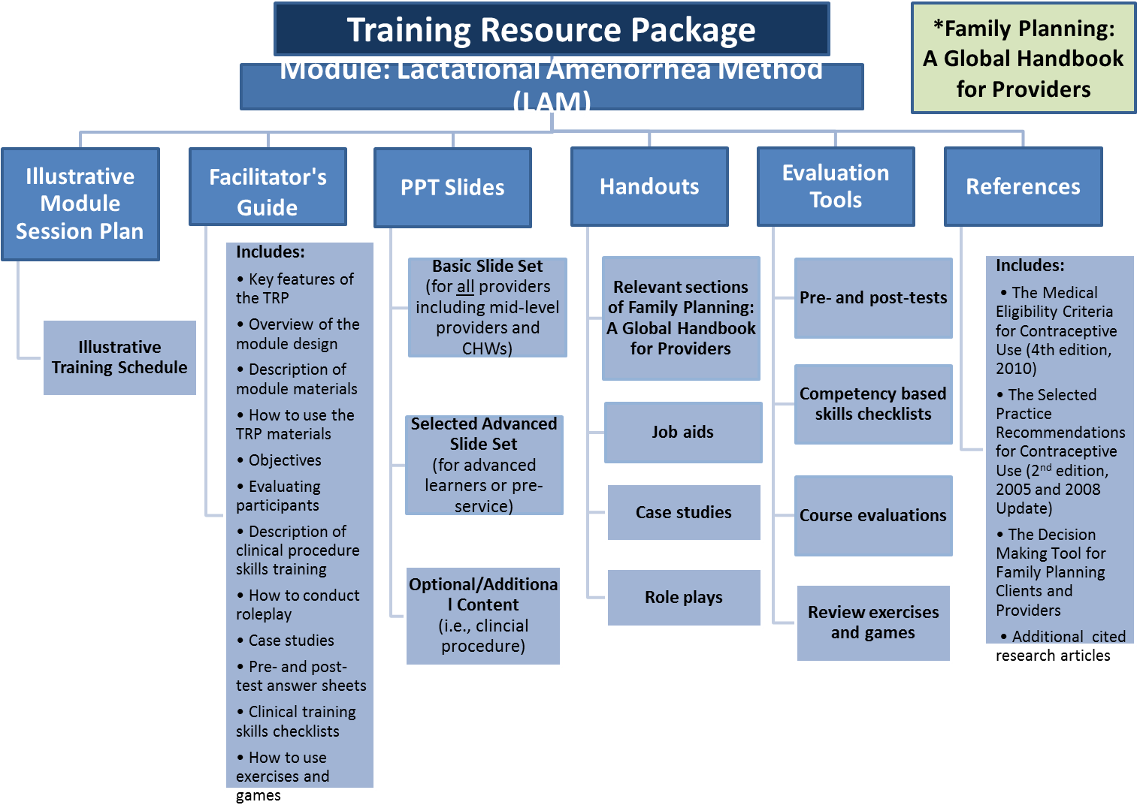
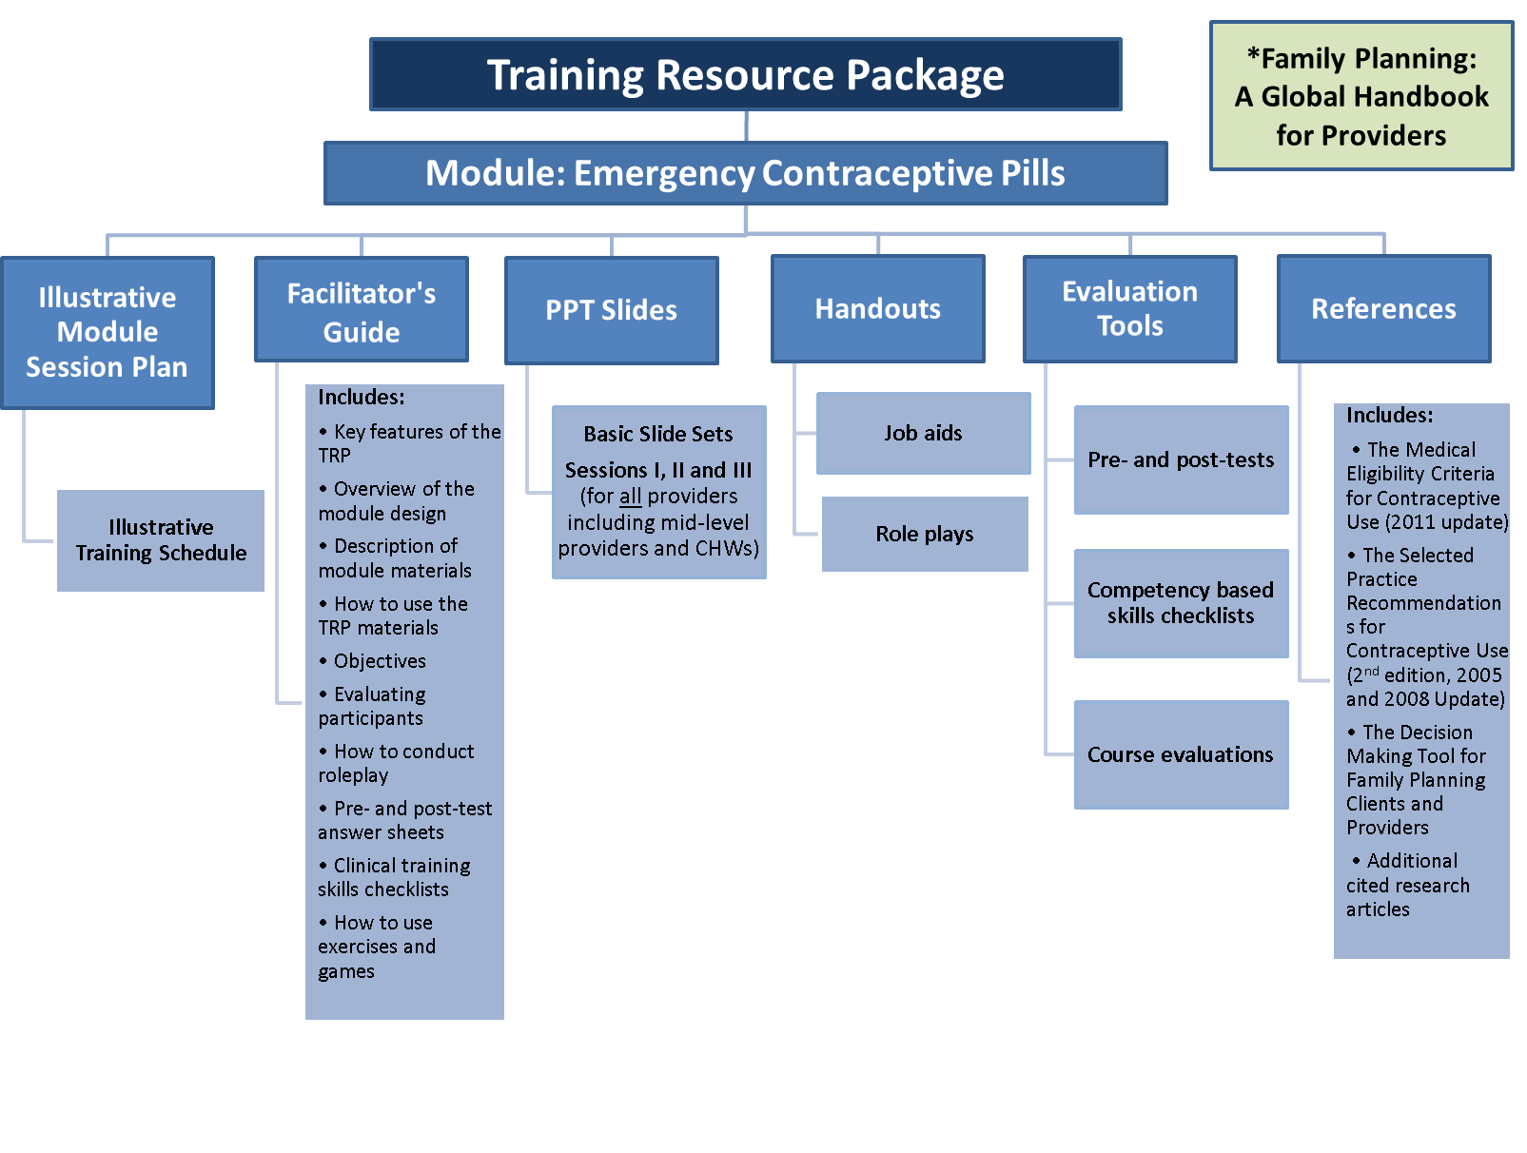
Emergency Contraceptive Pills (ECPs):
Facilitator’s Guide to the Training Resource Package
- What is the Training Resource Package Module on Emergency Contraceptive Pills (ECPs)?
This Facilitator’s Guide will help you make effective use of the ECP module of The Training Resource Package (TRP). The TRP module on ECPs is part of a global resource package for trainers, supervisors, and program managers. It contains user-friendly materials and resources for designing, conducting and evaluating training for family planning ECP providers. The resource package is specifically designed for trained mid-level providers and pharmacists can be adapted for use with lower-level community health workers.
- What is the Purpose of the Training Resource Package Module on ECPs?
This training manual was developed for use in training physicians, nurses, midwives, pharmacists and other health care providers allowed to counsel women on ECPs. It is designed to actively involve the trainees in the learning process. Sessions include PowerPoint presentations, simulation skills practice in the form of role plays, discussions, and clinical practice using objective competency-based skills checklists.
At the end of this module, the trainee will be able to describe ECPs, counsel and screen clients seeking ECPs, respond to rumors and misconceptions about ECPs, provide services for ECP clients, and provide follow-up care, including on-going contraception.
- Who Can Use the Training Resource Package Module on ECPs?
The training materials are designed to be used by clinical trainers and pre-service educators with a thorough understanding of adult learning principles and the ability to provide clinical training on ECPs in pre-service or in-service settings.
- Using the ECP Module to Develop Training
All of the parts needed to develop a curriculum for ECPs are included in the TRP module on ECPs. The diagram following the Table of Contents shows how the different elements of the module fit together. Each piece of the ECP module may be adapted to fit the circumstances in the country where they will be used, the trainers who will be conducting training, and the level of expertise and skills of the trainees. The module can be adapted to fit any kind of training e.g., face-to-face or self-study combined with clinical practicum, on-the-job training, etc. The module can be used as a stand-alone module or as part of a comprehensive course in FP. If the module is used as part of a comprehensive course, you may want to reduce the time allocated for some of the sessions by eliminating or shortening some activities, such as the experiential learning exercise on frequently asked questions. The module can be used as a resource for refresher training or for training new providers. Whenever possible, the module should be translated into the local language.

V. Using the Technical Resource Package Module on ECPs for Pre-service Training
Teachers and curriculum developers may use TRP resources for developing a new course or to create teaching materials for an existing pre-service curriculum. While many of the activities involved in developing in-service training also apply to pre-service curricula, developing pre-service curricula involves a distinctive set of coordinated activities. Describing how to use the TRP in this process would require more extensive instructions than this guide can currently provide.
- Overview of the Design of the Technical Resource Package Module on ECPs
Like all of the modules in the TRP, the ECP module is a complete package of learning resources needed to address the learning objectives of the module, including a session plan, PowerPoint presentations, and accompanying activities and resources. The module is designed for generic groups of health workers. The ECP module materials should be tailored and adapted according to the education and training background and learning needs of the identified trainees.
The module is designed for the providers in developing countries who most often are tasked with providing FP services—primarily nurses and nurse-midwives, as well as primary care physicians and in some cases pharmacists—and assumes trainees will have at minimum level of clinical training.
In order to understand the design of the modules, it is helpful to see the diagram on page three. The basic design includes the following:
- The Learning Objectives
By the end of the training, trainees should be able to:
1. Discuss the consequences of unwanted pregnancy.
2. Describe the characteristics of emergency contraceptive pills (ECP) in a manner that clients can understand:
a. What ECPs are and how they work (mechanism of action)
b. Effectiveness
c. Side effects
d. Safety
e. Possible precautions or complications
f. ECP regimens
g. Key points for providers and clients
3. Describe the indications for use of ECPs
4. Demonstrate how to screen clients for ECP use
5. Demonstrate counseling ECP clients including:
a. Characteristics of ECPs
b. How to address common concerns, myths and misconceptions about ECPs
c. How to use ECPs
d. Possible side effects of ECPs and how to manage them
e. The importance of starting regular contraceptives after ECP use
- Illustrative Module Session Plan with Illustrative Training Schedule
The session plan summarizes how the resources and documents in the module should be used to achieve the learning objectives. Each section of the session plan addresses a module topic, such as characteristics of ECPs or who can use ECPs. The slides to be shown with each section and appropriate handouts are identified. The ECP module is divided into three sessions:
- Session I is on the characteristics of ECPs and includes key points for providers and clients, effectiveness, and mechanism of action;
- Session II contains information on who can and who cannot use ECPs, medical eligibility for the use of ECPs, and information on screening for ECP use;
- Session III is on providing ECPs. It includes a review of when to start ECPs, key counseling topics for ECP users, correcting rumors and misunderstandings, and providing on-going contraception.
The Illustrative Training Schedule provides a snapshot of the breakdown of the module by day, time, and topic covered. For example:

DAY 1
Time | Topic | Method | Resources
8:00-8:15 | Welcome and Introduction  Learning Objectives | Discussion | Session I, Slide 2
8:15-8:45 | Pre-test | Test | Evaluation Tool: The ECP Pre-Test
8:15-8:45 | Session I: Characteristics of ECPs (50 min.)
8:15-8:45 | What are ECPs? | Discussion | Session I, Slide 5
8:15-8:45 | Explaining How ECPs Work | Lecturette | Session I, Slide 6

- Facilitator’s Guide
This Facilitator’s Guide contains information on the module design, a description of the materials, learning objectives, how to conduct role plays, pre- and post-test answer key, and sample course evaluation to be used by trainees to evaluate the training. The course evaluation is Handout #12.
The ECP module includes a set of role play scenarios that enable trainees to practice using the knowledge and skills they are learning. Each role play describes a typical client scenario and the tasks specific to that scenario. In addition, Facilitating Role Plays in Appendix B includes instructions for setting up and facilitating role plays, role play observation checklists for clinicians, and general instructions for the observer, provider, and client roles.
d. Presentation (PowerPoint slides)
The PowerPoint presentation includes technical information on ECPs. The slides also include Speaker’s Notes with instructions for activities and questions to ask. The Speaker’s Notes convey the same information found in the Session Plan.
e. Handouts
Job aids
The ECP module includes job aids that describe how and when to perform important provider tasks—for example, screening checklists. Learning activities in the module give trainees opportunities to practice using these job aids so they can more easily incorporate use of these tools at the workplace. Each job aid or handout is numbered.
Counseling tools
The ECP module activities can be used with a variety of counseling approaches and job aids. The term counseling tool in TRP materials refers to the counseling tool or job aid that trainees will be using. Examples include WHO’s Decision-Making Tool for Family Planning Clients and Providers, Balanced Counseling Strategy counseling cards or other approaches and tools. Facilitators should incorporate activities that enable trainees to use the counseling tool or job aids that they use at work (or will use after the learning intervention).
f. Evaluation Tools
The ECP module contains several options for evaluating trainees including pre- and post-tests which contain objective questions, with instructions for scoring the tests. The module also contains competency-based skills checklists and an optional review games.
Pre- and Post-tests
The pre-test knowledge evaluation should be given at the beginning of the course and again at the end of the course (post-test). The trainee’s pre- and post-test scores should be compared to measure changes in knowledge. The pre-test contains the same test items as the post-test. The pre- and post-tests are objective and comprised of true/false and multiple choice questions. Instructions are given on how to score the tests. There are also case studies included with the post-test. Grade the case studies separately. The case studies are a good way to determine whether trainees are able to apply the knowledge they have gained. The pre-test is Participant Handout #1 and the Post-test is Handout #10. The answer key is Appendix D of the Facilitator’s Guide.
Competency-based Skills Checklists
Trainers may observe trainees practicing and applying skills, tools, and techniques during the session. This can be done through direct observation of clinical skills and role plays.
A competency-based checklist is developed by breaking down the skill or activity to be taught into its essential steps. Each step is then analyzed to determine the most efficient and safe way to perform and learn it. These checklists make learning the necessary steps or tasks easier and evaluating the learner’s performance more objective.
Using checklists in competency-based clinical training:
- Ensures that trainees have mastered the clinical skills and activities;
- Ensures that all trainees will have their skills measured according to the same standard; and
- Forms the basis for follow-up observations and evaluations
Criteria for satisfactory performance by the trainees are based on the knowledge, attitudes, and skills demonstrated and practiced during training. In preparing for formal evaluation by the trainer, trainees can familiarize themselves with the content of the checklist by critiquing each other’s skills.
When evaluating the performance of a trainee, the trainer will judge each step of the skill to be:
1 = Needs Improvement: Step or task not performed correctly or out of sequence (if necessary) or is omitted
2 = Competently Performed: Step or task performed correctly in proper sequence (if necessary) but participant does not progress from step to step efficiently
3 = Proficiently Performed: Step or task efficiently and precisely performed in the proper sequence (if necessary)
Not observed: Step, task, or skill not performed by the trainee during evaluation by the trainer
The competency-based checklist for ECPs is Participant Handout#6 and can also be found in Appendix C of this Facilitator’s Guide.
Course Evaluations
The course evaluation is an important first step in determining the success of a training program. Trainees reactions help determine the effectiveness of a program and how it can be improved. The Course Evaluation can’t measure the ability to apply the learning, changes in attitudes or beliefs, organizational impact, or the trainer’s technical knowledge. A Sample Course Evaluation can be found in Appendix D of this Facilitator’s Guide and is Participant Handout #11.
Rapid evaluations can be done quickly to determine trainee’s reactions to the day’s session. Ask the following:
- How valuable was today’s session for you using a 5-point scale?
- What are the most important things you learned today?
- How do you plan to apply those ideas to your job?
If you choose not to use the course evaluation form, a quick alternative at the end of training (or during) is to put up two flip charts. On one flip chart write, “Here are some things we found especially useful in the training.” On the other write, “Here are some suggestions for how the training could be even better.” Make sure the trainer leaves the room while the trainees are writing.
- References
The main references for the ECP module as well as for other modules of the TRP are the World Health Organization’s four cornerstones of family planning guidance:
- Family Planning: A Global Handbook for Providers (2011 update).This book serves as a quick-reference resource for all levels of health care workers. It provides practical guidance on delivering family planning methods appropriately and effectively.
- The Medical Eligibility Criteria for Contraceptive Use (4th edition, 2010). This resource provides guidance on whether people with certain medical conditions can safely and effectively use specific contraceptive methods.
- Decision Making Tools for Family Planning Clients and Providers
- The Selected Practice Recommendations for Contraceptive Use (2nd Edition 2005) and the Selected Practice Recommendations for Contraceptive Use: (2008 Update).
Other resources used to develop the ECP module:
- The Alan Guttmacher Institute, News Release: Unplanned Pregnancy Common Worldwide, Neither Legal Status of Abortion nor Health Risk Deters Women from Terminating Pregnancies Four in 10 Pregnancies Unplanned--Half of Which End in Abortion, New York, N.Y.
- Chen J, Wang Y, Ren F, Yu W, Cheng L. “Pregnancy Outcome After Levonorgestrel-Only Emergency Contraception Failure: A Prospective Cohort Study”. Hum Reprod 2009;24(7):1605-11.
- Cleland K, Raymond E, Trussell J, Cheng L, Zhu H. “Ectopic Pregnancy and Emergency Contraceptive Pills: A Systematic Review”. Obstet Gynecol 2010;115(6):1263-6.
- De Santis M, Cavaliere AF, Straface G, Carducci B, Caruso A. “Failure of the Emergency Contraceptive Levonorgestrel and the Risk of Adverse Effects in Pregnancy and on Fetal Development: An Observational Cohort Study”. Fertil Steril 2005;84(2):296-9. Zhang L,
- Dominguez L, Downing D., Jordan B, Kurnik D, Schwarz E., Trussell J, and Westley E, “Emergency Contraception: Update for Pharmacists”, Pharmacy Today 2010(Jun);50(6):48–60.
- Farrell B, Solter C, Huber D, Vandenbroucke M, “Comprehensive Reproductive Health and Family Planning Training Curriculum, Module 5: Emergency Contraception”, Pathfinder International, May 1997 Revised September 2000.
- Gainer E, Kenfack B, Mboudou E, Doh AS, Bouyer J. “Menstrual bleeding patterns following levonorgestrel emergency contraception”. Contraception 2006;74(2):118-24.
Gynecology & Obstetrics (FIGO), Emergency Contraceptive Pills, Medical and Service Delivery Guidelines, Third Edition 2012
- International Consortium for Emergency Contraception (ICEC) and International Federation of Gynecology & Obstetrics (FIGO). “How do Levonorgestrel-Only Emergency Contraceptive Pills (LNG Ecps) Prevent Pregnancy? Statement on Mechanism of Action”. March 2012 (http:// www.cecinfo.org/publications/policy.htm, accessed 23 October 2012).
- International Consortium for Emergency Contraception and Sexual Violence Research Initiative, “EC for Rape Survivors, A Human Rights and Public Health Imperative”, September 2013.
- International Consortium for Emergency Contraception, “Clinical Summary: Emergency Contraceptive Pills”, February 2013.
- International Consortium for Emergency Contraception, “Emergency Contraception, Questions and Answers for Decision Makers”, February 2013.
- International Consortium for Emergency Contraception, “Emergency Contraception Regimen Update: Timing and Dosage of Levonorgestrel-alone Emergency Contraceptive Pills”, January 2013.
- International Consortium for Emergency Contraception, “The Unfinished Agenda: Next Steps to Increase Access to Emergency Contraception”, 2013.
- Logan C., Holcombe E., Manlove J., and Ryan S., “The Consequences of Unintended Childbearing: A White Paper, Child Trends, Inc., May 2007.
- Noe G, Croxatto HB, Salvatierra AM, et al. “Contraceptive Efficacy of Emergency Contraception with Levonorgestrel Given Before or After Ovulation”. Contraception 2011;84(5):486-92.
- PATH, “Youth-Friendly Pharmacy Program Implementation Kit: Guidelines and Tools for Implementing a Youth-Friendly Reproductive Health Pharmacy Program”, 2013.
- Piaggio G, Kapp N, von Hertzen H. “Effect on Pregnancy Rates of the Delay in the Administration of Levonorgestrel for Emergency Contraception: A Combined Analysis of Four WHO Trials”. Contraception 2011;84(1):35-9.
- Raymond E, Taylor D, Trussell J, Steiner MJ. “Minimum Effectiveness of the Levonorgestrel Regimen of Emergency Contraception”. Contraception 2004;69(1):79-81.
- Raymond EG, Goldberg A, Trussell J, Hays M, Roach E, Taylor D. “Bleeding Patterns after Use of Levonorgestrel Emergency Contraceptive Pills”. Contraception 2006;73(4):376-81.
- Raymond EG, Halpern V, Lopez LM. “Pericoital Oral Contraception with Levonorgestrel: A Systematic Review”. Obstet Gynecol 2011;117(3):673-81.
- Santelli J., Rochat R., Hatfield-Timajchy K., Colley Gilbert B., Curtis K., Cabral R., Hirsch J., Schieve L., and Other Members of the Unintended Pregnancy Working Group, “The Measurement and Meaning of Unintended Pregnancy,” Perspectives on Sexual and Reproductive Health, Volume 35, Number 2, March/April 2003
- Trussell J, Raymond E, Cleland K, “Emergency Contraception: A Last Chance to Prevent Unintended Pregnancy”, July 2014.
- Wilcox AJ, Weinberg CR, Baird DD. “Timing of Sexual Intercourse in Relation to Ovulation. Effects on the Probability of Conception, Survival of the Pregnancy, and Sex of the Baby”. N Engl J Med 1995;333(23):1517-21.
- World Health Organization. “Emergency Contraception Fact Sheet No. 244”. July 2012
- World Health Organization. “Fact Sheet on the Safety of Levonorgestrel-Alone Emergency Contraceptive Pills (LNG ECPs)”. June 2010.
- The World Health Organization, “Framework for Ensuring Human Rights in the Provision of Contraceptive Information and Services”, 2014.

Appendices
Appendix A: Illustrative Training Schedule
Time | Topic | Method | Resources
8:00-8:15am | Welcome and Introduction | Discussion | Basic Slide Set: Session I, Slide 2
8:15-8:45am | Pre-test | Test | Evaluation Tool: The Emergency Contraceptive Pills (ECPs) Pre-Test
8:45-10:00am | Session I: Characteristics of ECPs (2 hrs.15 min.)
8:45-10:00am | Overview of Objectives | Discussion | Session I, Slides 2 and 3
8:45-10:00am | What is unintended pregnancy? | Discussion | Session I, Slide 4
8:45-10:00am | Values clarification | Learning Exercise
8:45-10:00am | Legal framework for ECPs | Discussion
8:45-10:00am | What ECPs are and how they work | Brainstorming | Session I, Slides 5 and 6
8:45-10:00am | Effectiveness of ECPs | Lecturette | Session I, Slides 7 and 8
8:45-10:00am | Side effects of ECPs | Lecturette | Session I, Slide 9
10:00-10:15am Tea Break
10:15am-12:30pm | No contraindications to ECPs | Discussion | Session I, Slide 12
10:15am-12:30pm | ECP regimens | Lecturette | Session I, Slides 13 and 14
10:15am-12:30pm | Key points for providers and clients | Lecturette | Session I, Slide 15
10:15am-12:30pm | Session II: Who Can and Cannot Use Emergency Contraceptive Pills (20 min)
10:15am-12:30pm | Indications for the use of ECPs | Discussion | Session II, Slides 2 and 3
10:15am-12:30pm | Screening clients for ECP use | Discussion | Session II, Slides 4 and 5
10:15am-12:30pm | Session III, Providing Emergency Contraceptive Pills (1 hr. 45 min)
10:15am-12:30pm | Counseling ECP clients | Discussion | Session III, Slides 2 and 3
12:30pm – 1:30pm Lunch
1:30pm-3:30pm | Myths and misconceptions about ECPs | Brainstorming | Session III, Slides 4, 5 and 6
1:30pm-3:30pm | How to use ECPs | Brainstorming | Session III, Slide 7
1:30pm-3:30pm | Possible side effects and how to manage them | Discussion | Session III, Slide 8
1:30pm-3:30pm | Counseling clients | Roleplays | Handout #5
1:30pm-3:30pm | Follow-up and referral for clients | Discussion | Session III, Slides 9 and 10
1:30pm-3:30pm | Starting regular contraception after ECP use | Lecturette | Session III, Slides 11 and 12
3:30pm-3:45pm Tea Break
3:45pm-4:45pm | Frequently asked questions | Lecturette | Handouts 8 and 9
3:45pm-4:45pm | Post-test and course evaluation |  | Handouts 10 and 11
3:45pm-4:45pm | Closing

Appendix B: General Guidance for Facilitating Role-Plays
Role-plays are designed to give participants an opportunity to practice using the technical knowledge they have gained in reality-based situations that simulate their workplace. Role-plays that relate to various core and method-specific objectives are included throughout the FPTRP. If placed and employed correctly during training, role-playing provides participants an opportunity to reflect, build on existing experience, and apply new knowledge/skill sets in situations that closely match their day-to-day experiences.
Trainers should follow these general steps in preparing for and conducting a role-play.
Preparing for the Activity
- Read the role-plays carefully and select the situations that are similar to the clients and circumstances of the participants. Review the client and observer cards for each situation and become familiar with the issues under consideration in each situation. If necessary, adapt the role-play to make it consistent with the situations that providers are likely to encounter in their workplace (e.g., type of facility, titles of job aids, and cultural practices of clients).
- Anticipate and know how to address issues raised in the role plays you select. Study the technical information in Family Planning: A Global Handbook for Providers (CCP and WHO 2007, updated 2011) related to the issues raised in the role-play situations.
- Be familiar with the tools and/or job aids that participants are expected to use when carrying out the role-play (e.g., checklist for screening clients who want to initiate a particular method, a counseling flip book or client brochure to help describe characteristics of the client’s chosen method and how to use the method). Be prepared to demonstrate proper use of a tool or job aid to describe the relative effectiveness of various contraceptive methods.
- Decide how you would like to use the role-plays with the participants. If it is the first time that the participants are using the FPTRP approach to role-plays, it is recommended that you conduct a demonstration of how the role-plays should be conducted so that participants are familiar with the expectations related to the various roles. Select a role-play to use for demonstration purposes and practice your demonstration. Also practice how you will provide instructions to the participants.
Conducing the Activity
- Introduce the activity to the participants by explaining that they will now be given an opportunity to build on their experience while putting some of their new knowledge, skills, and tools into practice in situations that simulate interactions that they may have with clients in their workplace. Provide the specific learning objectives associated with the role-play exercise (e.g., Participants will practice, in role-play format, best techniques for conducting screening interviews for clients who have expressed an interest in using the ECPs.” Remember, if this is the first time that participants are doing role-plays, conduct a role-play demonstration so that participants learn how to use the materials and understand how the activity will be processed in their small groups and as a large group.
- Ask participants to break into small groups of three participants each. Ask each group to decide who will play the client, who will play the provider, and who will be the observer – all participants will have an opportunity to play each role (groups do not need to do the same role-play at the same time).
- Distribute copies of the role-play description to the participants who will play the client and the observer. Also distribute copies of the Training Resource – Counseling Observation Checklist to the observers and the Training Resource – Provider Instructions for Counseling Role Plays to those playing providers. Ask the clients and observers not to show the role-play scenario to the person who is playing the provider. (Handout #5). Provide the Competency-based checklist for ECPs (Handout #6) so that all of the participants can see what is expected of them when providing ECPs.
Instruct the clients that prior to beginning the role-play, they should reveal only their sex to the provider. Other personal information included in the role-play description should be shared with the provider only when the provider solicits it by asking appropriate questions. Clients should also pick a name for their character and reveal it when asked by the provider.
Instruct the providers to follow the guidance summarized in the Provider Instructions for Counseling Role-Plays. Remind them that during the role-plays, they should facilitate a decision-making process with the client; as appropriate, integrate information about other RH issues; and assist the client to act on his or her decision(s).
Instruct the observers to use the Counseling Observation Checklist to take notes on what happens between the provider and client. The observer should record, in the space provided on the checklist, whether and how well the provider addresses these issues during the role-play and be prepared to give feedback to the provider regarding how well they addressed the client’s needs (e.g., uncover and help the client deal with anxiety, facilitate communication with the partner, and allow the client to make an informed decision.)
- Give the groups 15 minutes to conduct the mock sessions. At the conclusion, ask the groups to take about 5 minutes to talk about what happened during the role-play from the perspective of the provider (self-assessment), the client (personal satisfaction with the interaction), and the observer (objective assessment using the Counseling Observation Checklist). The groups should discuss the following questions among themselves (post a prepared flip chart, or a Powerpoint slide, of the discussion questions where each small group can see it):
- What was going on between the provider and client?
- What did the provider do that was effective in this situation?
- What might the provider consider doing differently if this situation were to happen again?
- How did the provider attend to the items on the counseling observation checklist and the case-specific observations included in the role-play description?
Rotate roles and substitute new role-plays so that each participant practices the provider role at least twice. Encourage participants to provide constructive criticism during their post-role-play discussions and to take breaks as needed between role-plays.
- After the small groups have completed one round of role-plays (each participant has had an opportunity to play each role), process the activity in the large group using the discussion questions below:
While playing the role of the provider
- How did it feel to integrate new content, techniques, and job aids into your counseling session?
- What worked well? What still feels awkward and requires more practice?
- What did you think about the length of the counseling sessions?
- Did the client raise issues or questions that you were not sure how to answer?
While playing the role of the client
- What did you think about the session?
- Were you able to absorb the information provided?
- Were all your concerns addressed?
- Were you comfortable asking questions?
- Were you satisfied that your main reason for coming to the clinic was adequately addressed?
While playing the role of the observer
- Did you think that the providers were able to create a comfortable environment and build adequate rapport with their clients?
- Can you share some examples that you observed in the role-plays?
- Ask the participants to return to their small groups and take turns practicing another set of role-plays so that each participant has a second opportunity to play the role of the provider.
- After the small groups have completed a second round of role-plays (each participant has had an opportunity to play each role twice), repeat the discussion in the large group using the questions in step #5 above. Conclude this activity by reminding participants that with practice, counseling sessions can become a time-efficient and essential component of the services that ensure that the reproductive health needs of their clients are met.

Provider Instructions for Role Plays
Pretend that you are meeting the client for the first time. Ask the client for his or her name and age. Pretend that there is a health center nearby to which you can refer the client, if needed. Remember to:
- Address the reasons for the client’s visit
- Facilitate the client’s decision-making process
- Integrate information and services related to other RH issues as appropriate
- Help the client act on her or his decision(s)
Apply your prior experience along with what you have learned from the training and use job aids and tools as appropriate to address the client’s concerns.

Observer Instructions for Role Plays
Prior to the start of the interaction:
- Review the Role Play Observation Checklist so that you are familiar with the behaviors that you are observing and where they appear on the checklist
- Review the case-specific issues on the observer information sheet for the role play
While observing the interaction between the provider and client, remember to:
- Use the observation checklist to take notes on what happens during the interaction
- Record how well the provider addresses the case-specific issues in the space provided
- Be prepared to give feedback to the provider regarding how well he or she addressed the client’s needs
Pay particular attention to whether the provider:
- Helped the client deal with anxiety
- Facilitated communication with a partner
- Allowed the client to make an informed decision
- Verified that the client understood instructions
- Helped the client carry out her decision

Client Instructions for Role Plays
Prior to the start of the interaction:
- Read the client information sheet and make sure you understand your character’s situation
- Pick a name for your character. Tell the provider your name, age, and whether you are male or female
During the interaction, offer information only when the provider asks relevant questions. Use the information given in your client information sheet to respond to the provider’s questions. Feel free to ask questions of the provider.

Training Resource – Counseling Observation Checklist
Case: ____________________________ Provider: _______________________________ Client: _______________________________ Observer: _______________________________ Date: ___________________________
Overall  Establishes and maintains rapport  Shows respect and is nonjudgmental  Uses simple, clear language  Actively listens to client  Attends to client’s emotional needs  Encourages client participation  Ensures client understanding and corrects misunderstandings  Uses appropriate nonverbal communication (body language)  Ensures confidentiality and privacy  Offers to involve client’s partner (as appropriate)  Uses job aids appropriately (if available)  Assess Client’s Needs and Concerns  Asks about reason for visit  Explores sexual behavior and risks and need for protection | Yes | No | N/A | Provide Information and Options Related to Client’s Concerns  Advises on safer sex, STI and HIV prevention  Advises on pregnancy prevention/contraceptive methods (side effects)  Advises on client’s other identified issues or concerns  Facilitates analysis of options in context of client’s situation  Determines whether ECPs are appropriate for the client  Provide Assistance to Support Client’s Decision  Provides contraceptive method following ECP use and instructions on correct use  Gives instructions and demonstrates correct use of ECPs  Offers and gives condoms  Ensures comprehension of facts and implications  Arranges follow-up visit for supplies, health check, etc.  Arranges referral to outside services (for client or partner as applicable) | Yes | No | N/A

Role Play Scenario 1
ECPs Scenario 1—Client Information Sheet | ECPs Scenario 1—Observer Information Sheet
Client Description  You are a 21-year old woman who is seeking ECPs today. You had unprotected sex with your new boyfriend the night before last, and your best friend told you to go to a provider and ask about pills that can prevent you getting pregnant. The first day of your last menstrual period was two weeks ago. You usually use condoms, but this time you didn’t have any around and hadn’t expected to have sex. You’d like to know if the provider can give you some of these pills to keep at home in case this ever happens to you again.  Offer this information only when the provider asks relevant questions:  You don’t know very much about your new boyfriend and don’t know whether he has ever had an STI.  Your periods are usually very regular.  You have never used a contraceptive other than condoms | Make note of whether the provider performs these case-specific tasks:  Asks client why she has come to you or what makes her think he/she needs ECPs.  Asks client what she has heard about ECPs.  Tells client about ECPs (how they work, effectiveness, possible side effects).  Uses open-ended and probing questions appropriately  Listens carefully to client (paraphrase and reflect)  Explains what will occur during visit  Asks all of the screening questions  Shows the client how to use ECPs  Tells client the menstrual period is likely to be within one week before or after the normal expected date.  Provides the client with ECPs to take home but also provides information about available contraceptive methods which are effective and cost less.  Ensures client understanding and corrects misunderstandings

Emergency Contraceptive Pills
Role Play Scenario 2—
ECPs Scenario 2—Client Information Sheet | ECPs Scenario 2—Observer Information Sheet
Client Description  You are a young woman. Several days ago you were assaulted and raped, and you think you may need ECPs to prevent you from pregnancy. You go to the clinic to find out more information. The provider asks screening questions. You begin to feel nervous and are reluctant to tell the provider that you have been raped.  Offer this information only when the provider asks relevant questions:  You were assaulted. This happened 48 hours ago  The first day of your last period was two weeks ago  Your periods are usually very regular | Make note of whether the provider performs these case-specific tasks:  Asks client why she has come to you or what makes her think he/she needs ECPs.  Asks client what she has heard about ECPs.  Tells client about ECPs (how they work, effectiveness, possible side effects).  Uses open-ended and probing questions appropriately  Listens carefully to client (paraphrase and reflect)  Explains what will occur during visit  Asks all of the screening questions  Shows the client how to take the ECPs  Tells client the menstrual period is likely to be within one week before or after the normal expected date.  Ensures client understanding and corrects misunderstandings  *Note: Use local guidelines for post-rape counseling and prevention of STDs

Emergency Contraceptive Pills
Role Play Scenario 3—
ECPs Scenario 3—Client Information Sheet | ECPs Scenario 3—Observer Information Sheet
Client Description  You are 15 years old. You had never had sex until 3 nights ago. That night, you had sex with your boyfriend for the first time. You had not planned to have sex and neither of you had a condom. You are worried that you might be pregnant.  Offer this information only when the provider asks relevant questions:  - Your periods are not regular. Sometimes they vary between 3 weeks and 5 weeks.  - You don’t think that you need contraception because you and your boyfriend will not have sex again. This was a mistake and you want to be married before you have sex again. | Make note of whether the provider performs these case-specific tasks:  Asks client why she has come to you or what makes her think he/she needs ECPs.  Asks client what she has heard about ECPs.  Tells client about ECPs (how they work, effectiveness, possible side effects).  Uses open-ended and probing questions appropriately  Listens carefully to client (paraphrase and reflect)  Explains what will occur during visit  Asks all of the screening questions  Shows the client how to take the ECPs  Tells client the menstrual period is likely to be within one week before or after the normal expected date, but that she should return to the clinic if her menstruation has not occurred after 2 weeks.  Ensures client understanding and corrects misunderstandings
Emergency Contraceptive Pills
Role Play Scenario 4—
ECPs Scenario 4—Client Information Sheet | ECPs Scenario 4—Observer Information Sheet
Client Description  You are a 41-year-old woman with three teenage boys and a two-year-old girl (who was a surprise baby following the removal of an IUD). You and your husband have been using condoms every time you had sex, but the night before last, you were out of condoms and had sex without a condom. You are concerned that you might become pregnant. It has been 2 weeks since your last menstrual period.  Offer this information only when the provider asks relevant questions:  - You have no serious health problems and have a regular menstrual cycle.  - You used the IUD in the past but were not pleased with the heavy bleeding and cramping. | Make note of whether the provider performs these case-specific tasks:  Asks client why she has come to you or what makes her think he/she needs ECPs.  Asks client what she has heard about ECPs.  Tells client about ECPs (how they work, effectiveness, possible side effects).  Uses open-ended and probing questions appropriately  Listens carefully to client (paraphrase and reflect)  Explains what will occur during visit  Asks all of the screening questions  Shows the client how to take the ECPs  Tells client the menstrual period is likely to be within one week before or after the normal expected date.  Provides the client information about contraceptive methods and either provides the method or refers the client to a place where contraceptive methods are available

Role Play Scenario 5—
ECPs Scenario 5—Client Information Sheet | ECPs Scenario 5—Observer Information Sheet
Client Description  You have heard about ECPs from friends and think you might need it, but you are scared to take them because you think they might make you infertile and that it might not be safe because you smoke. You had unprotected sex last night (you were not expecting to have sex with your new boyfriend and did not have any contraceptive protection nearby). Your last menstrual period ended 5 days ago and was normal. You are a smoker and have herpes but no other health  problems. You have been pregnant once before and had an abortion and are scared of having another one. You are interested in learning more about ongoing contraception.  Offer this information only when the provider asks relevant questions:  - You think that you might have an STD. | Make note of whether the provider performs these case-specific tasks:  Asks client why she has come to you or what makes her think he/she needs ECPs.  Asks client what she has heard about ECPs.  Tells client about ECPs (how they work, effectiveness, possible side effects).  Uses open-ended and probing questions appropriately  Listens carefully to client (paraphrase and reflect)  Explains what will occur during visit  Asks all of the screening questions  Shows the client how to take the ECPs  Tells client the menstrual period is likely to be within one week before or after the normal expected date.  Discusses contraceptive options  Ensures client understanding and corrects misunderstandings

Appendix C: LNG Emergency Contraceptive Pills (ECPs)
Pre/Post Test Answer Key
*Note to the Facilitator on how to grade the pre and post test: Count each correct answer as one point. Answers such as “all of the above” or “none of the above” count as one point. Each correct answer in the multiple choice questions should count as one point. The total number of correct answers should add up to 20. Multiply the number of correct answers times 5 to get the percent. The passing score is usually 80% or above.
Multiple Choice
For each of the following questions, circle the letter(s) of the correct answer(s).
- Contraindications to LNG ECPs include:
- Migraine headaches with aura
- High blood pressure
- Diabetes with kidney, eye, or nerve damage.
- None of the above

- Which of the following are acceptable ECP regimens
- Levonorgestrel (LNG) 1 tablet, 1.5 mg
- LNG 2 tablets of 0.75mg taken 12 hours apart
- LNG 2 tablets of 0.75mg taken at one time
- All of the above

True or False
Circle true or false for each statement.
- ECPs are indicated when a contraceptive was used, but failed. | True | False
- ECPs are indicated for a woman who is 3 months postpartum, is breastfeeding and is worried because her menstruation has not started. | True | False
- ECPs are indicated for a woman who was raped 4 days ago. | True | False
- ECPs are indicated for a woman who is taking oral contraceptives but forgot to take her pills 3 times during the past week. | True | False
- LNG ECPs work primarily by preventing or delaying ovulation | True | False
- Vomiting after taking LNG ECPs is common. | True | False
- Side effects from LNG ECPs usually resolve within 24 hours. | True | False
- LNG ECPs are not harmful if accidentally taken once a woman is already pregnant. | True | False
- Taking ECPs prevents pregnancy only from acts of sex that took place within the last 5 days. | True | False
- LNG ECPs have the same contraindications as regular oral contraceptive pills. | True | False
- LNG ECPs may be more effective the sooner they are taken after unprotected sex. | True | False
- It may be unsafe for a girl of 14 to take LNG ECPs | True | False
- ECPs are indicated for a married couple who did not use a contraceptive. | True | False
- LNG ECPs can cause an abortion if a woman is already pregnant. | True | False
- Once fertilization has occurred, ECPs will not work. | True | False

Yes or No Questions
For each of the following mini-case studies, state whether you would provide the woman with ECPs by answering yes or no.

- Your customer is 15 years old and had unprotected sex 2 days ago. When you go through the screening checklist, you find that her menstruation is very irregular. She says that her menstruation is sometimes 3 weeks apart and sometimes 5 weeks. Her last menstruation was 3 weeks ago. Should you give her ECPs? | Yes | No
- Your customer is 17 years old and had unprotected sex last night. When you see her, you recognize her. She came several times last month requesting ECPs. You are concerned that she is using ECPs as regular contraception. Should you give her ECPs again? | Yes | No
- A woman is breastfeeding. She had unprotected sex 4 days ago. Can you give her ECPs? | Yes | No

Case Study Answer Key (Case studies are to be given only during the post-test, not during the pretest.) These case studies do not count as part of the post-test score, but can be used to determine whether participants are able to apply what they have learned.
For the following scenarios, what should you advise the client?
A young man comes to the clinic. He says that he was with his girlfriend and the condom broke. She is too embarrassed to come to the clinic. What would you do?
Answer: You should encourage the young man to bring his girlfriend to the clinic. In addition to providing ECPs there are other things that you may want to discuss with the young woman, such as STI prevention and whether or not she is in a safe and comfortable relationship. If she absolutely refuses and your clinic policy allows, give the ECPs to her boyfriend and instruct him on how she should take the ECPs and what to expect. Encourage him again to have his girlfriend come to the clinic for access to more effective forms of contraception.
A client has been using the injectable contraceptive DMPA. She went to a family wedding and missed her last injection by at least 4 weeks, possibly 5. She had unprotected sex. You give her ECPs, but what should you tell her about continuing contraception?
Answer: Advise her to use condoms until her next menstruation and then begin DMPA again or choose another contraceptive.
A client has missed 3 combined oral contraceptive pills (COCs) in a row. You give her ECPs. What advice should you give about contraception?
What advice would you give her about continuing COCs?
What advice would you give her about when she can start other contraceptives?

Answer: Your client needs a back-up method for first 7 days. She can continue using COCs, one tablet daily up to the next menstrual bleeding, then start a new pack on the first day of the menstrual cycle.
Or
Stop using COCs. Use a condom until the next menstrual period and then resume taking COCs with a new packet
Or
Use condoms until the next menstrual period. Then, within the first 7 days of menstruation, begin using DMPA, or have an IUD or implant insertion.

